##### 

**Signature**

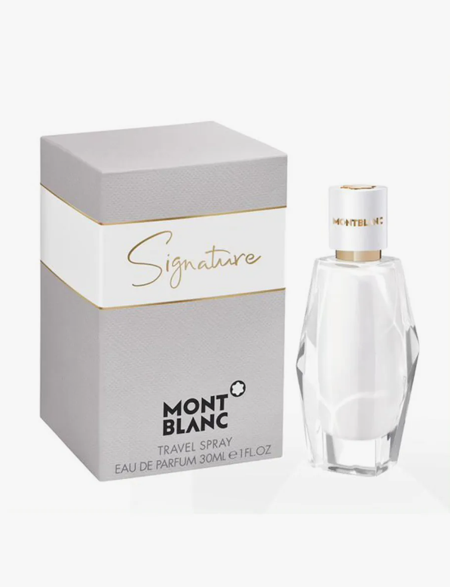**Signature** by **Montblanc** is a Amber Floral fragrance for women. **Signature** was launched in 2020. Signature was created by Guillaume Flavigny and Natalie Gracia-Cetto. Top note is Clementine; middle notes are Magnolia, Ylang-Ylang and Peony; base notes are Vanilla, White Musk and Benzoin.

Montblanc's new women's perfume is called Montblanc Signature, announced as an oriental-floral and musky fragrance intended for unforgettable women, "authors of their own story." The face of the campaign is Diane Ducret, a French-Belgian writer.

Signature plays with contrasts of opulent and sensual vanilla and the "clean" facets of white musk. Fresh fruity notes of clementine at the top are combined with a floral heart of magnolia and ylang-ylang. The composition are composed by perfumers Guillaume Flavigny and Natalie Gracia-Cetto.

"With this appeal and elegance, I wanted to infuse more light, more breath and transparency", explains Natalie Gracia-Cetto.

Top notes: clementine  
Heart: magnolia, peony, ylang-ylang  
Base: benzoin, white musk, vanilla

The opalescent bottle of perfume, the white lacquering on the inside, is a tribute to the iconic inkwell, part of Montblanc's heritage. It was designed by Montblanc's own Mark Eisen. The gold details are borrowed from the Meisterstück writing instrument.

Montblanc Signature is available as a 30, 50 and 90 ml Eau de Parfum.